NAME: SAGARSUMAN P MANJHI SUBJECT: PYTHON PROGRAMMING LAB | PRACTICAL: 03 | BATCH : 04  SYBVOC :SEM-III (DS)
Experiment Based on Tuple, Dictionary and Set Data Structures

AIM : To write a Python program to demonstrate the use of different data structures — Tuple, List, Set, and Dictionary — for storing and displaying student information such as name, roll number, subjects, hobbies, and marks, along with performing basic operations like insertion, deletion, searching, updating, and traversal.
LEARNING OBJECTIVE :
  - To understand Python data structures.
  - To learn the use of Tuple, List, Set, and Dictionary.
  - To store and display student information.
  - To perform basic operations on data structures.
  - To improve programming and logical thinking skills.
TOOLS :

Sr. No. | Name Of Resources | Specification | Quantity | Remarks
1. | Hardware | Computer (i5-i7) Ram (Min 16GB) | 1 | For All Practical
2. | Software | Python / IDLE / VS Code | 1 | For All Practical
THEORY :
1. Tuple: A tuple is an ordered and immutable collection of elements. It is written using parentheses ().
Example:
student = ("SAGARSUMAN MANJHI", 101)
2. List: A list is an ordered and mutable collection of elements. It is written using square brackets []. We can add, remove, and modify elements in a list.
Example:
subjects = ["Python", "Maths", "English"]
3. Set: A set is an unordered collection of unique elements. It is written using curly braces {}. Duplicate values are automatically removed.
Example:
hobbies = {"Music", "Cricket", "Reading"}
4. Dictionary: A dictionary stores data in key-value pairs. It is written using curly braces {}, with each key separated from its value by a colon :.
Example:
marks = { "Python": 85, "Maths": 80, "English": 75}
5. Basic Operations: Python data structures support operations such as insertion, deletion, searching, updating, and traversal. These operations help us store, access, modify, and display data efficiently.
Source Code:
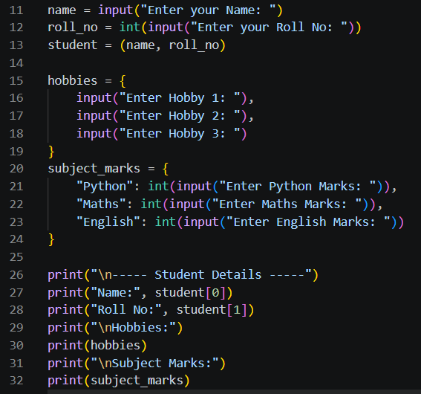
Output:
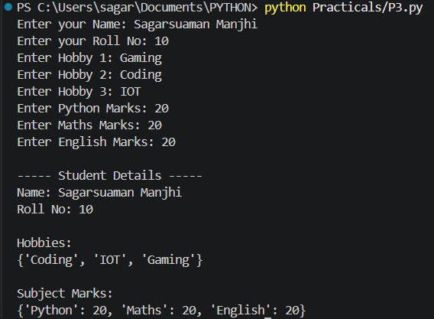
Result and Discussion:
The program successfully demonstrates the use of Tuple, List, Set, and Dictionary data structures in Python to store and display student information. It performs insertion, deletion, searching, updating, and traversal operations. It also calculates the total and average marks of the student.
Learning Outcomes:
- Understood the concept of Tuple, List, Set, and Dictionary.
- Learned to store and display student information.
- Learned to perform insertion, deletion, searching, and updating operations.
- Understood the use of loops and conditional statements.
- Learned to calculate total and average marks using Python.
Course Outcomes:
- Learned Developed Python programs using different data structures.
- Applied fundamental programming concepts to a practical problem.
- Understood data manipulation and iteration.
- Improved logical thinking and problem-solving skills.
CONCLUSION :
The Student Information Management program successfully demonstrates the use of Tuple, List, Set, and Dictionary in Python. It explains how student details, subjects, hobbies, and marks can be stored, accessed, modified, and displayed using different data structures.

VIVA QUESTIONS :
1. What is a data structure?
A data structure is a way of organizing and storing data so that it can be accessed and modified efficiently.
2. What is a Tuple in Python?
A tuple is an ordered and immutable collection of elements. It is written using parentheses ().
Example:
student = ("SAGARSUMAN MANJHI", 101)
3. What is a List in Python?
A list is an ordered and mutable collection of elements. It is written using square brackets [].
Example:
subjects = ["Python", "Maths", "English"]
4. What is a Set in Python?
A set is an unordered collection of unique elements. It is written using curly braces {}.
Example:
hobbies = {"Music", "Cricket", "Reading"}
5. What is a Dictionary in Python?
A dictionary stores data in key-value pairs.
Example:
marks = {"Python": 85, "Maths": 80}

FOR FACULTY USE ONLY :
Correction Parameters | Formative Assessment [40%] | Timely completion of practical [40%] | Attendance/ Learning Attitude [20%]
Marks Obtained

